**Assignment 1**

**The due date for submitting this assignment has passed.**

**Due on 2018-08-15, 23:59 IST.**

**Score:**10/10=100%

**Assignment submitted on 2018-08-13, 10:43 IST**

***1 point***

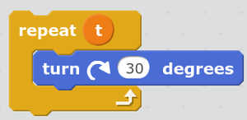  
  
What should be the value of **t** so that the sprite shall complete one full rotation?

 3

 6

 9

 12

**Yes, the answer is correct.   
Score: 1**

**Accepted Answers:**

*12*

***1 point***

Which of the following can be used to communicate across multiple sprites?

 broadcast messages

 wait option

 sounds options

 join operator

**Yes, the answer is correct.   
Score: 1**

**Accepted Answers:**

*broadcast messages*

***1 point***

  
  
Which of the following can never be an output of the above statement?

 3

 6

 9

 12

**Yes, the answer is correct.   
Score: 1**

**Accepted Answers:**

*12*

***1 point***

Which of the following options was used to make the sprite disappear from the animation stage?

 disappear

 vanish

 hide

 show

**Yes, the answer is correct.   
Score: 1**

**Accepted Answers:**

*hide*

***1 point***

Which of the following is a facility provided by Scratch to use sound effects?

 A sound library is provided

 We can record sound using a microphone

 We can use a sound file

 All of the above

**Yes, the answer is correct.   
Score: 1**

**Accepted Answers:**

*All of the above*

***1 point***

In addition to an option of using the inbuilt sprite library in Scratch, what are the other way(s) to use a sprite?

 You can paint a custom sprite

 Upload an image file from your computer

 You can use camera to take pictures

 All the above

**Yes, the answer is correct.   
Score: 1**

**Accepted Answers:**

*All the above*

***1 point***

Given first name and last name of a person, which of the following operators in Scratch can be used to obtain the full name?

 merge

 join

 combine

 concatenate

**Yes, the answer is correct.   
Score: 1**

**Accepted Answers:**

*join*

***1 point***

Which of the following commands would make the sprite move backwards?

 Move 10 steps

 Move -10 steps

 Both (a) and (b)

 Neither (a) nor (b)

**Yes, the answer is correct.   
Score: 1**

**Accepted Answers:**

*Move -10 steps*

***1 point***

Which of the following constructs carries out a set of instructions as long as any key in the keyboard is pressed?

 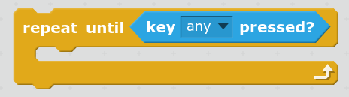

 

 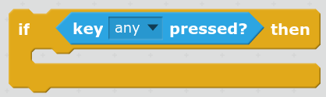

 None of the above

**Yes, the answer is correct.   
Score: 1**

**Accepted Answers:**

**

***1 point***

Which of the following Scratch constructs are used to keep doing a set of instructions infinitely?

 continue

 always

 forever

 do

**Yes, the answer is correct.   
Score: 1**

**Accepted Answers:**

*forever*